Day 8

Class Exercise 2

@PostMapping("/product")

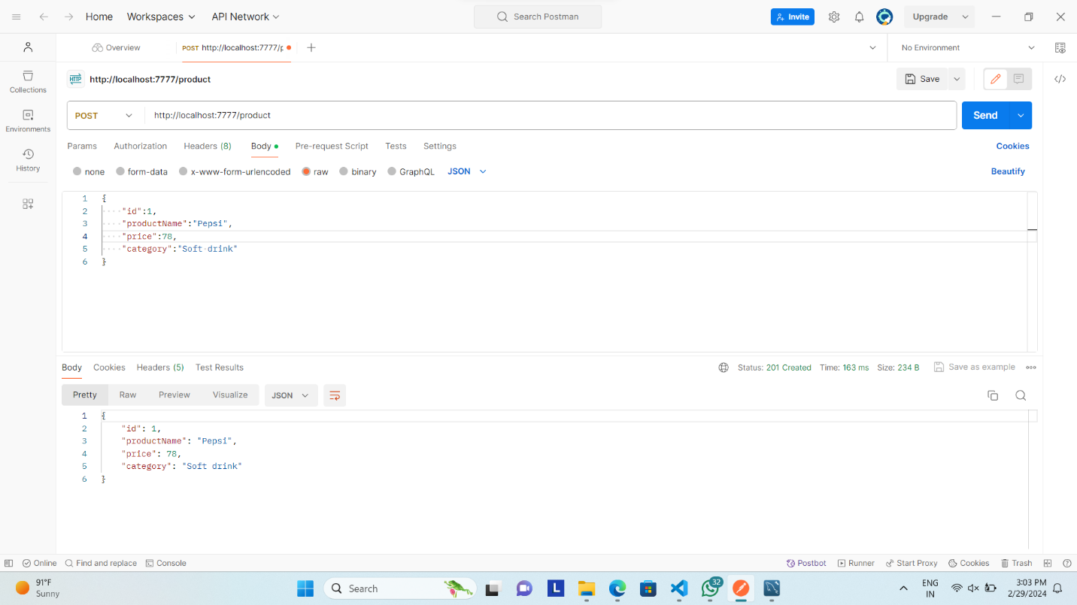

@GetMapping("/product/distinct/startwith/{name}")

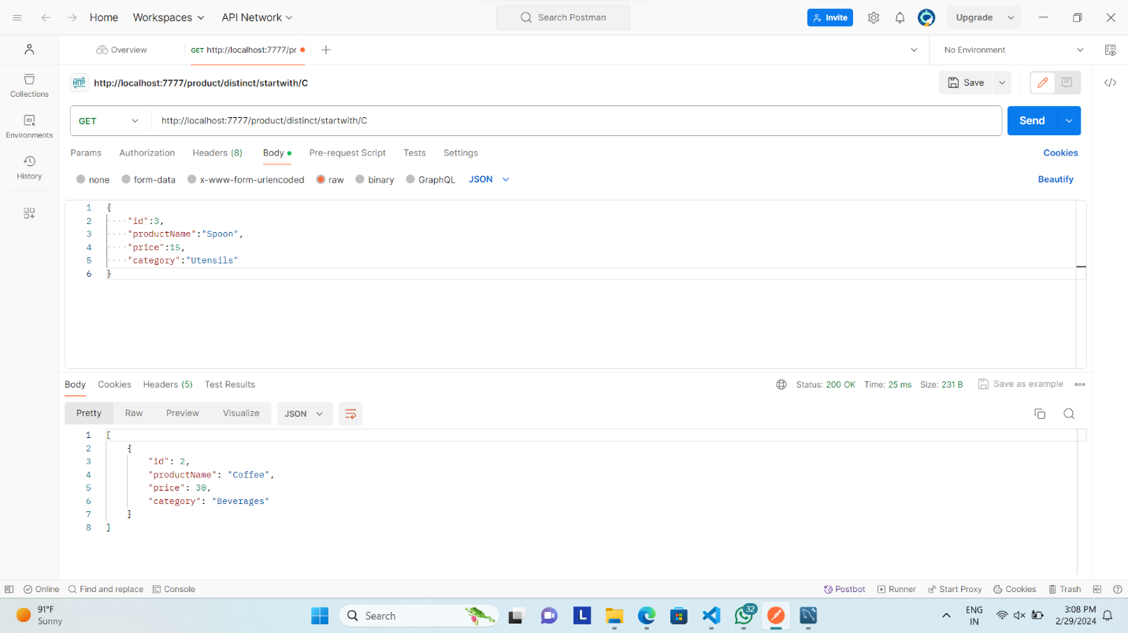

@GetMapping("/product/sortBy/price")

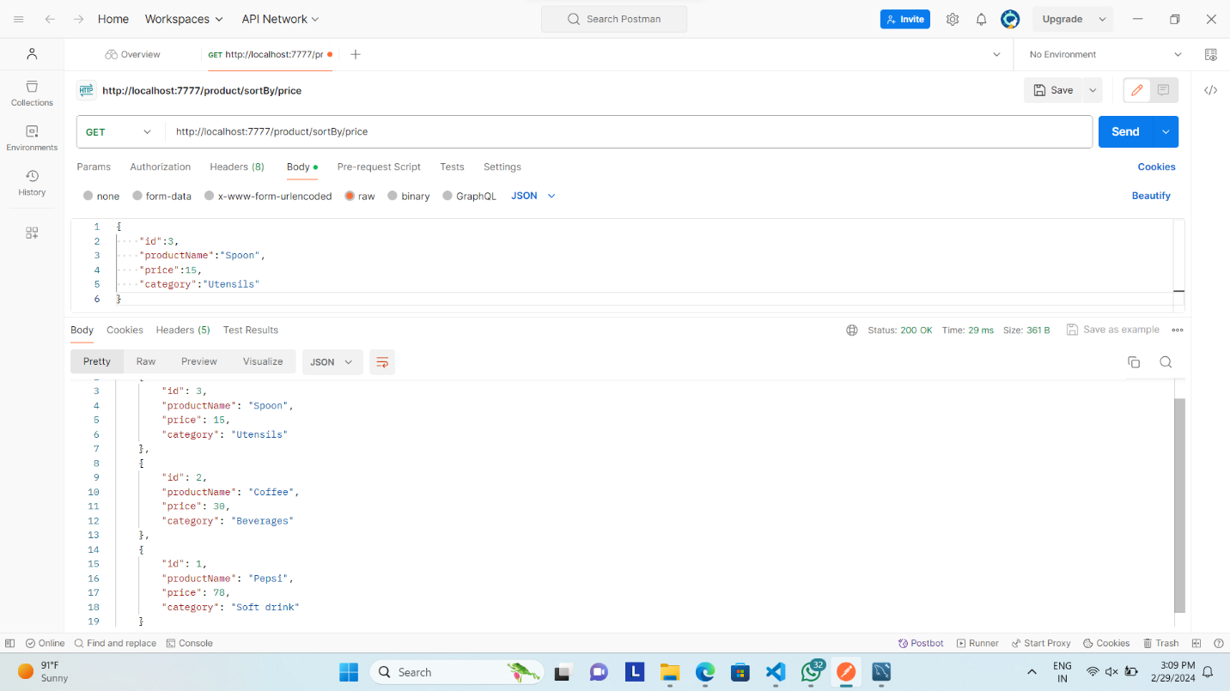

@GetMapping("/product/distinct/endwith/{name}")

